Biography – Cyndi Thau
From time spent outdoors and traveling to time spent in the studio Cyndi has always wanted to keep art as a central focus in her life. Originally from Arizona, Cyndi attended college at Arizona State University where she obtained a degree in design from the College of Architecture. She later obtained a second degree in computer graphic design. Upon graduation Cyndi had an opportunity to live and work in Alaska at a remote fly-out fly fishing lodge where she was able to observe the wildlife and culture that abounds. Between seasons in Alaska Cyndi spent five months in South America. She studied at a Spanish language school in Ecuador followed by working in a remote section of Chile.

Following Alaska, Cyndi relocated to a tranquil coastal village in Costa Rica where she could focus on her studies in the Spanish language along with her desire to become a full-time artist. She spent seven years owning and operating an art gallery in addition to her own creations which included paintings, murals and mosaics. It was during this time that the love of painting flowers developed. “I am fascinated by the forms, colors, depth and the play of light and shadow that interact to make a painting. I use thin layer upon layer of oil paint to achieve the translucency that I associate with all things in nature”.

For many years Cyndi resided in the peaceful region of Oak Creek Canyon, north of Sedona Arizona. Here she continued her oil painting with the glazing technique, becoming an instructor of this method. In recent years Cyndi studied the Plein Air style, painting from direct observation. Water, in specific the creek and ocean, are her favorite subjects. “I love translating the movement of water onto canvas. Always flowing, never still, the reflection of light on and through water are both a challenge and a delight to capture”.

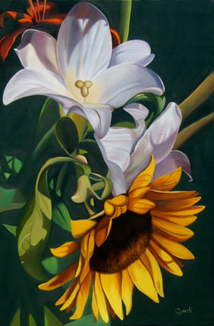
Cyndi now resides in the Panhandle region of Florida where she can paint the water she so loves. Dividing her time between the studio glazing technique and painting outdoors en plein air Cyndi continues to create oil paintings with the depth and translucency she is known for.

As a full-time Artist Cyndi strives to create work that is both inspiring to her and welcoming to the collector. Color, form and light are the ingredients of these paintings.

